DATA STRUCTURES AND ALGORITHMS

Week 1:
Mandatory Exercises:
Exercise 2:
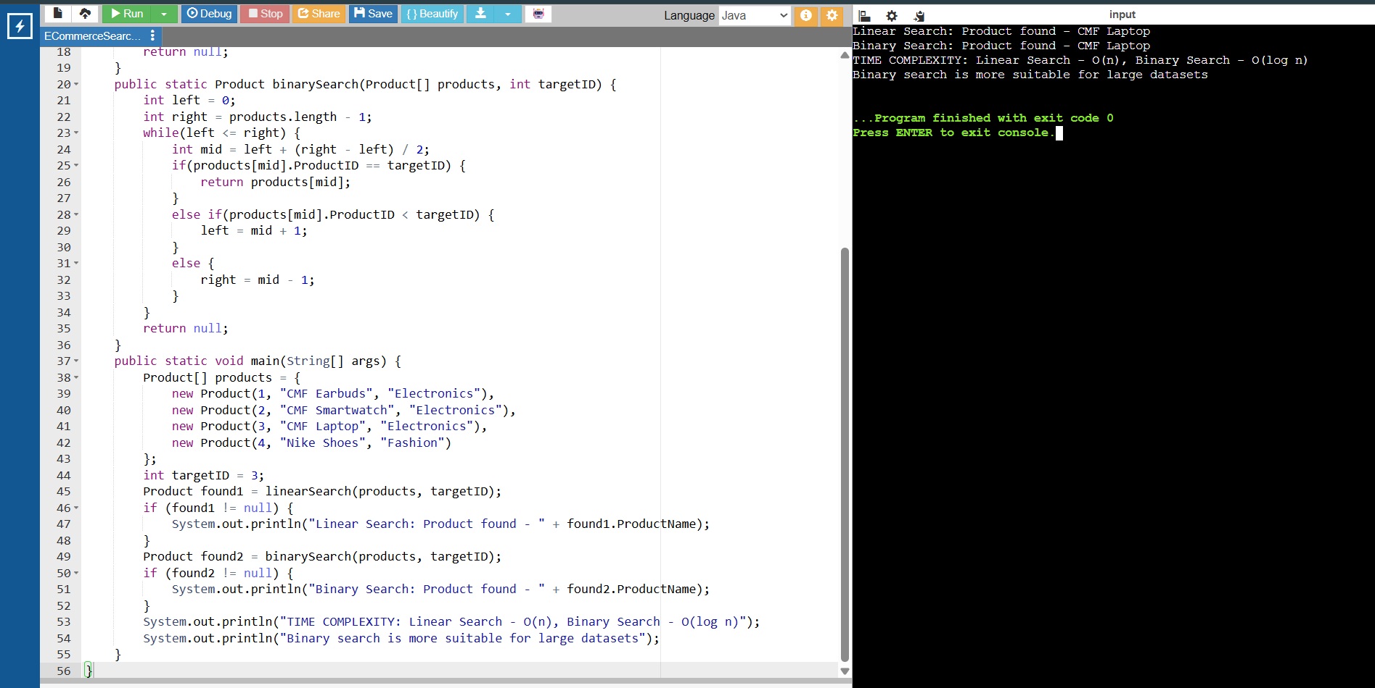

Exercise 7:
